**Data Factory – Create Pipelines and Activities**

In this example, we’ll copy from a Blob to a SQL database.

Click the Create pipeline icon:

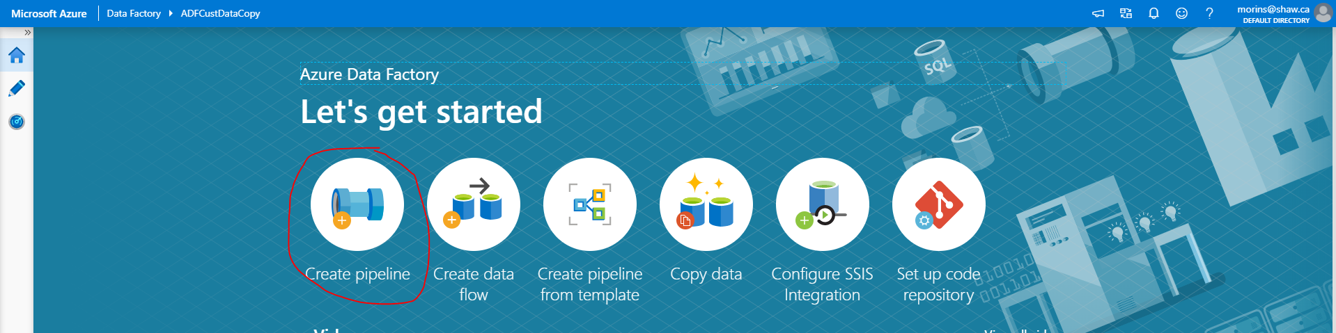

Next drag the activity you need onto the canvas:

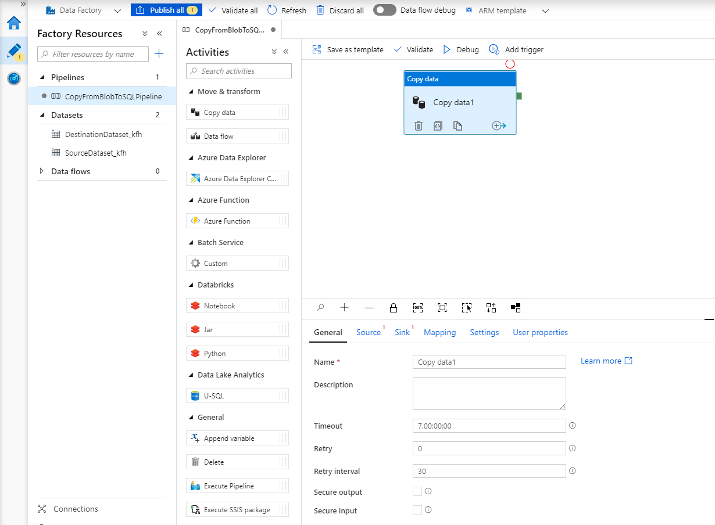

Click on the Source tab and select source:

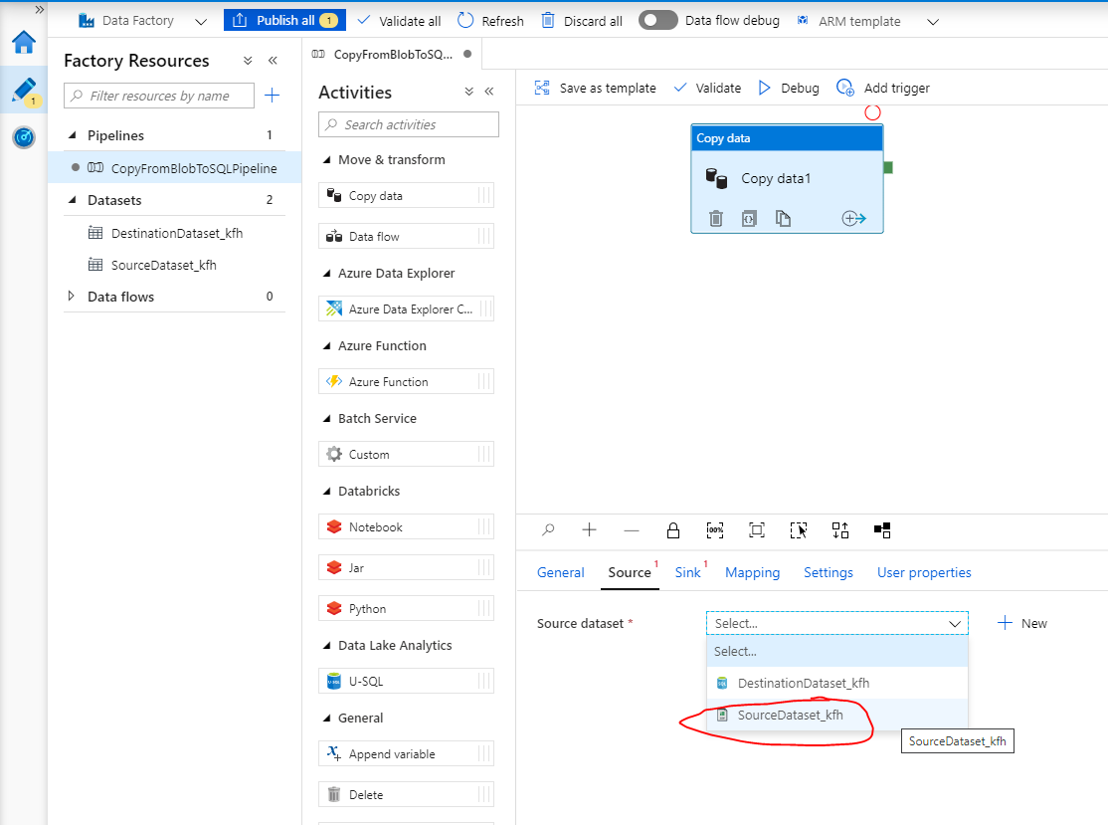

Configure Source settings as needed:

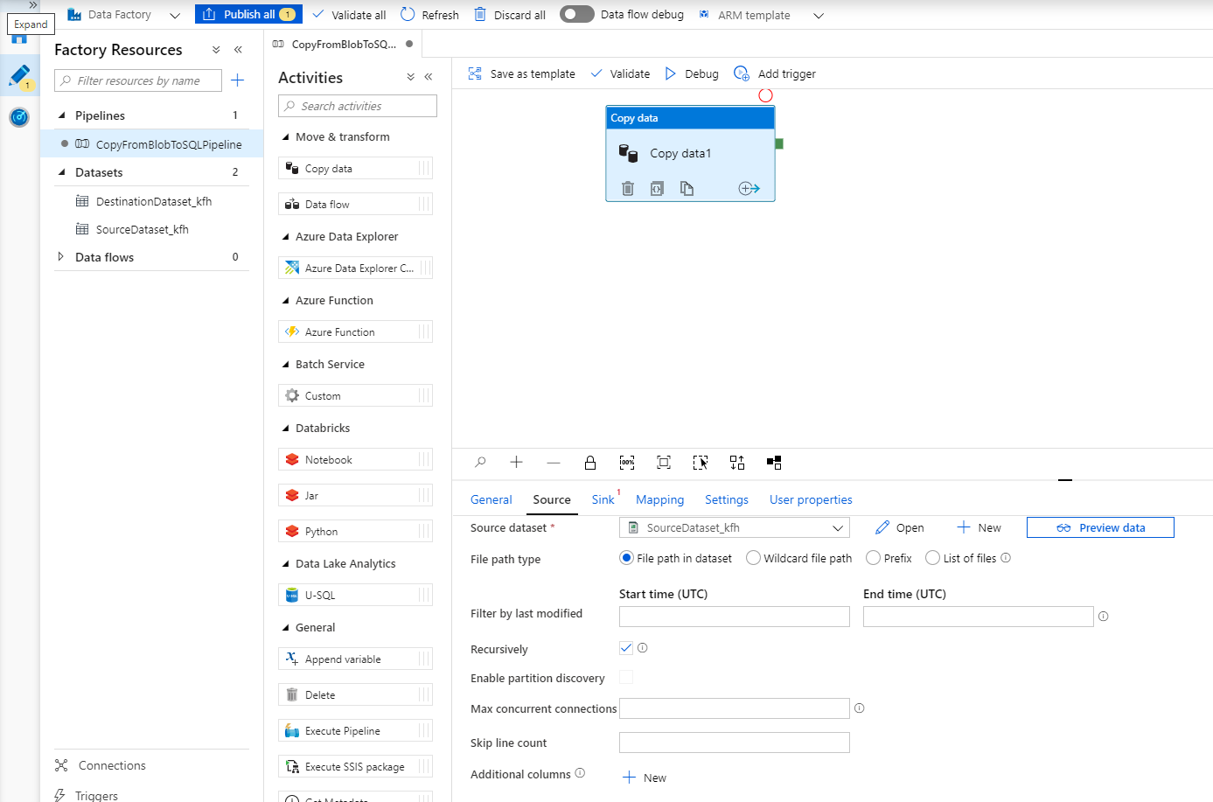

Select the sink Dataset:

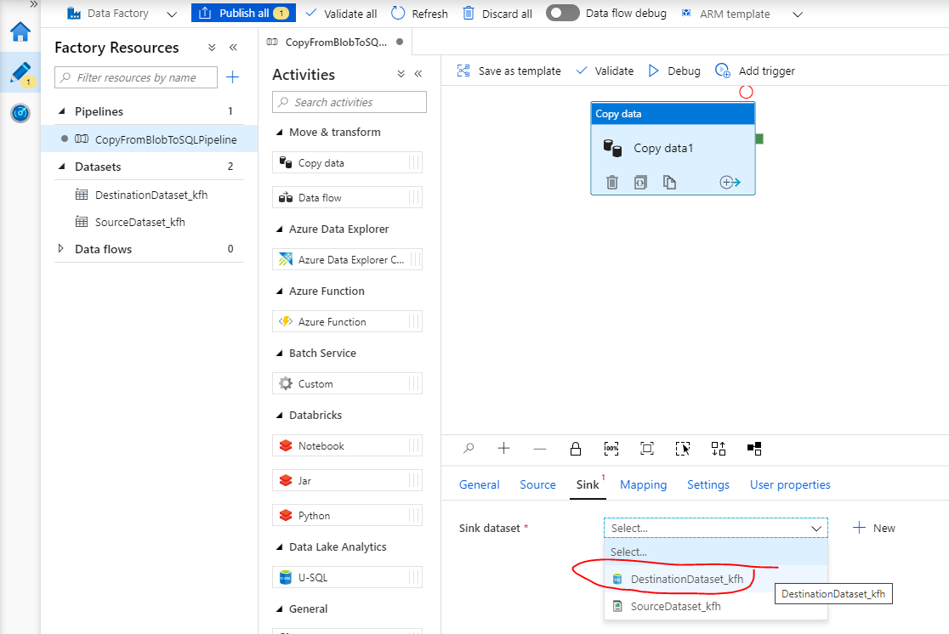

Fill in the details of the Sink dataset:

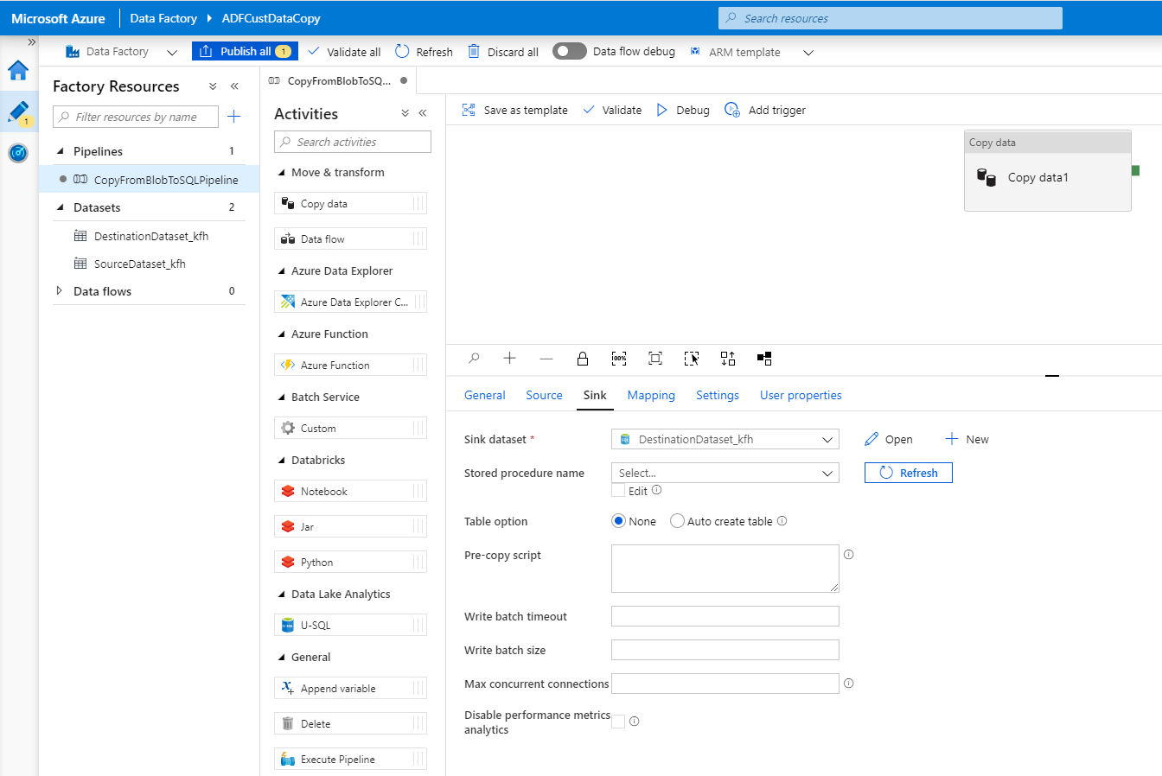

Next, go to the Mapping tab, and click ‘import schema’:

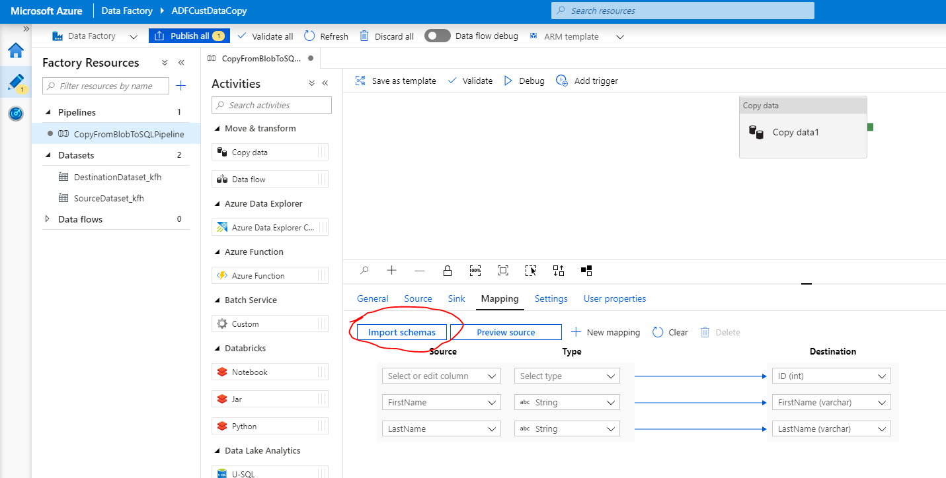

Remove mappings that have no data in the Source dataset.

Next, publish the Pipeline and test it!

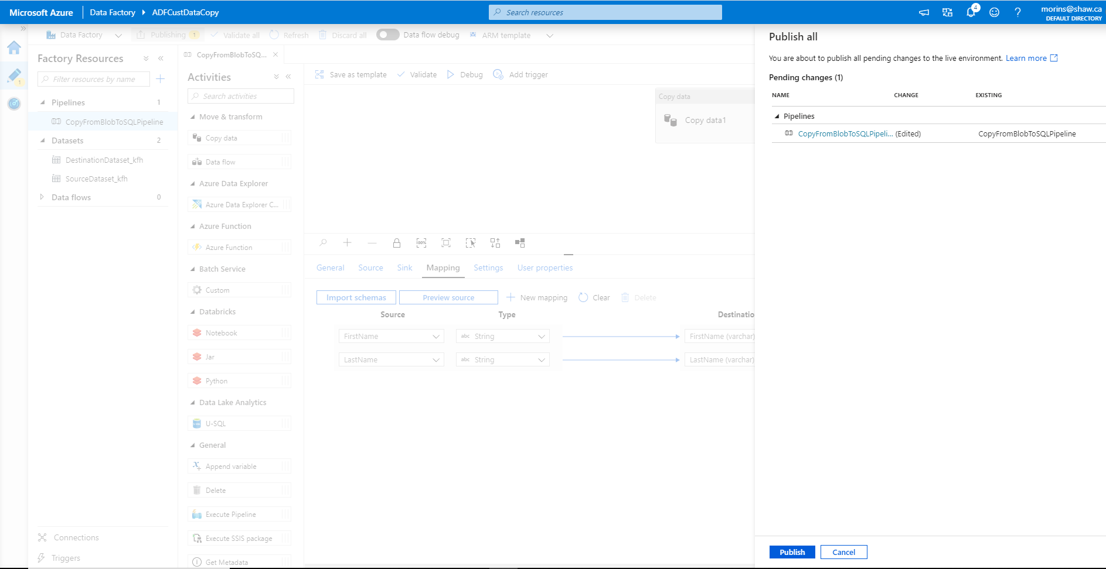

Click on the Monitor widget to view Pipeline runs:

